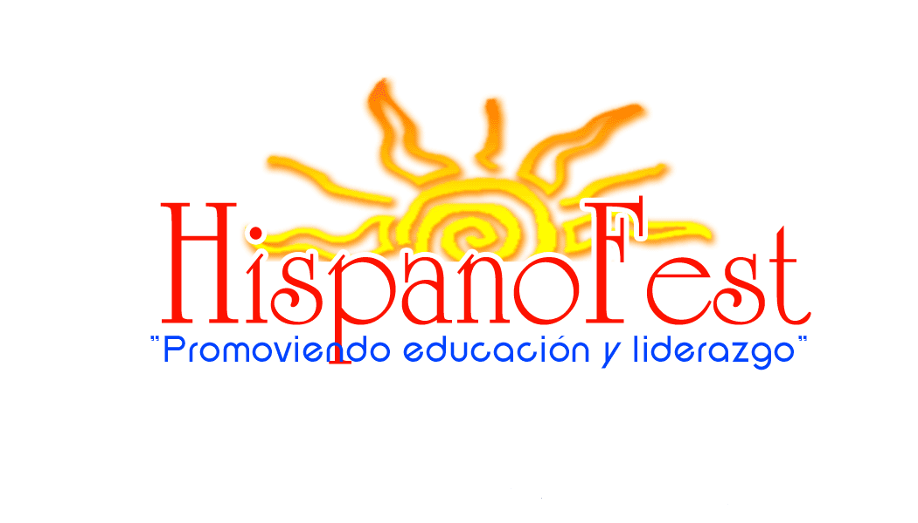

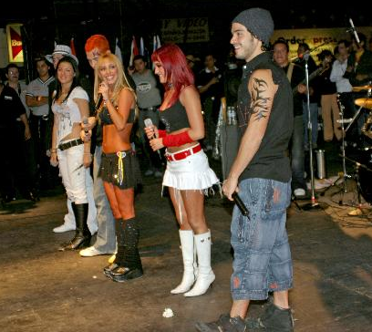
Rebelde 2005
Presenting Sponsor
$25,000 in monetary donation plus

- Presenter of entire HispanoFest festivities.
- Announced as presenter of HispanoFest at any fundraiser events that may be produced throughout and up until the festival.
- Award (2) two scholarship recipients in your company’s name.
- One (1) 10X10 exhibitor’s booth in prime location at festival.
- Banner placement at every stage and main entrance*.
- Company sponsorship mentioned before and after every music performance.
Corporate Sponsorship Package
- 24-Hour Announcement of HispanoFest presenter on digital billboard at 25th Avenue and North Avenue for 2 weeks prior to festival.
- Logo link to your company on HispanoFest Website.
- Corporate logo on all promotional materials.
- Five (5) VIP parking tickets.

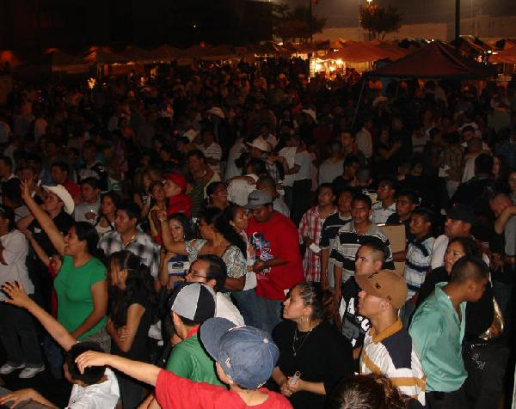
Other Categories
$15,000 in monetary donation plus

- Main STAGE SPONSOR.
- Award (1) one scholarship recipients in your company’s name.
- One (1) 10X10 exhibitor’s booth in prime location at festival.
- Banner placement at Main Stage and main entrance*.
- Company sponsorship mentioned after every music performance on Main Stage only.
- Corporate logo on all promotional materials.
- Five (5) VIP parking tickets.

$10,000 in monetary donation plus

- Second STAGE SPONSOR.
- Your company mentioned as a group sponsor for (1) one scholarship recipient.
- One (1) 10X10 exhibitor’s booth at festival.
- Banner Placement at Second Stage and main entrance*.
- Company sponsorship mentioned after every music performance on Second Stage only.
- Corporate logo on selected promotional materials.
- Two (2) VIP parking tickets.

$7,500 in monetary donation plus

- A 10X10 exhibitor’s booth at festival.
- Banner placement at main entrance.
- Company sponsorship mention at beginning and at the end of the festival for both days.
- Corporate name included on selected promotional materials.
- Two (2) VIP parking tickets.

HispanoFest P.O. Box 1902 Melrose Park IL 60161 www.hispanofestmelrosepark.com

Small Business Sponsor
$2,500 or more
(Promotional Advertising Package worth $7,500)
Small Business Package

- Banner placement at Main Stage*
- Company sponsorship Main and Second Stage mention at beginning and at end of festival for both days.
- Corporate Ad included on large 12’ X 24’ Billboard at Main Entrance
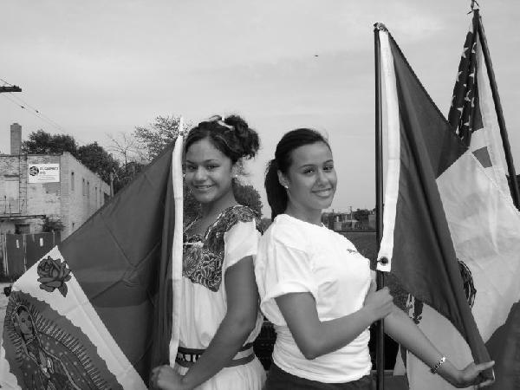
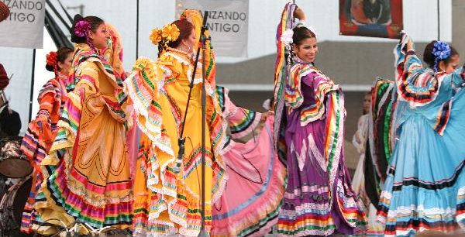
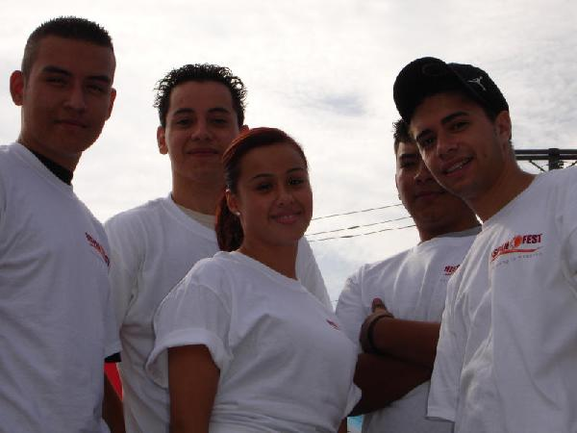
$1,000 or more
(Promotional Advertising Package worth $5,000)

- Banner placement at Second Stage*
- Company sponsorship Main Stage mention at beginning and at end of festival for both days.
- Corporate Ad included on large 12’ X 24’ Billboard at Main Entrance

$500 or more
(Promotional Advertising Package worth $1,000)

- Banner placement at Second Stage*
- Company sponsorship Second Stage mention at beginning and at end of festival for both days.
- Corporate Ad included on large 12’ X 24’ Billboard at Main Entrance

$250 or more
(Promotional Advertising Package worth $500)

- Company sponsorship stage mention at beginning and at end of festival for both days.
- Corporate Ad included on large 12’ X 24’ Billboard at Main Entrance
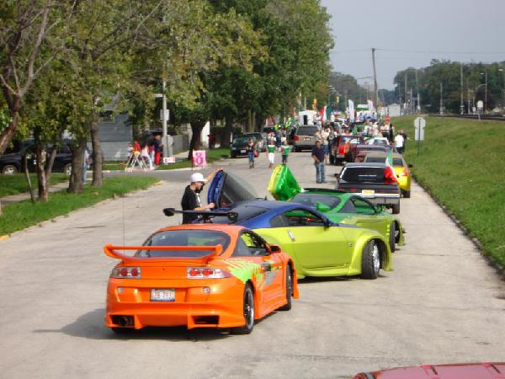
$100 or more
(Promotional Advertising Package worth $250)

- Corporate Ad included on large 12’ X 24’ Billboard at Main Entrance

*ALL BANNERS MUST BE PROVIDED BY THE SPONSOR AND POSTED BY THE SPONSOR AT THEIR APPROPRIATE LOCATION. HISPANOFEST WILL NOT BE RESPONSIBLE FOR LOST OR STOLEN BANNERS.

ALL SPONSORS CAN PARTICIPATE IN THE HISPANOFEST PARADE!!!

HispanoFest P.O. Box 1902 Melrose Park IL 60161 www.hispanofestmelrosepark.com

Commitment Form

Name of Company (As it should appear on promotional material)

Address:

City: |  |  | State: |  |  | Zip Code:
Name of Contact Person:

Phone numbers | Work: |  |  | Fax:
Phone numbers | Cell: |  |  | Email:
Phone numbers | Other:

Yes, _______________________________________________ would like to participate in this (Name of Company)

years 2026 HispanoFest event. Please include us as a sponsor for the amount of $________________

Form of payment will be mailed by what date? ______________________________________

Will you be participating in the September 12, 2026 Parade? Yes No
How? By float, convertible, horse etc.? ____________________________________________

Will your company be donating an in-kind donation? Yes No
If so, please describe___________________________________________________________

___________________________________ __________________
Commitment Signature of Company Representative Date
______________________________ _______________
Name (Please print) Title

Upon receipt of commitment confirmation by HispanoFest, an invoice with instructions for submission of logo and benefit confirmation will be forwarded to the contact person listed on this document. Please fax Commitment Form and Letter of Agreement to (866) 328 1694. Please endorse and mail all donations to:

Hispanofest 2026

Attn: Irene Herrera
P.O. Box 1902
Melrose Park, IL 60161
www.hispanofestmelrosepark.com
Email: hispanofest@yahoo.com

Hispanofest is recognized as a tax-exempt organization from federal income tax. Hispanofest is currently exempt under section 501 (c)(3) of the Internal Revenue Code. Hispanofest is also classified as a public charity under 509 (a)(1) and 170 (b)(1)(A)(vi) of the Internal Revenue Code. Any and all contributions to Hispanofest are deductible under section 170 of the Code, and Hispanofest qualifies to receive deductible bequests, devises, transfers or gifts under section 2055, 2106 or 2522 of the Internal Revenue Code.
HispanoFest P.O. Box 1902 Melrose Park IL 60161 www.hispanofestmelrosepark.com
HispanoFest is compiled of local business owners, Village of Melrose Park employees, community volunteers and the continued support of the Mayor of Melrose Park Ronald Serpico. HispanoFest is also a non-for-profit 501(c)(3) of the Internal Revenue Code and also classified as a public charity under sections 509(a)(1) and 170(b)(1)(A)(vi).
Mission: HispanoFest promotes the advancement to the Hispanic Community through educational and leadership development.
Festival: Because HispanoFest is an educational based organization; the festival is a family oriented atmosphere. The festival brings together Latin foods (45 food exhibitors), arts and crafts (45 booths), entertainment and a children’s carnival all in one location.
HispanoFest History
How do we do it? HispanoFest is possible because of ongoing fundraising of our major sponsors, our sales of booths and the vendor commitment. HispanoFest also accomplishes their goals by fundraising through the residents and business owners in the community. This major event allows the committee to award scholarships to local Hispanic students that live in the surrounding suburbs and are currently attending a college, university, or a trade school. Over the past 35 years HispanoFest has awarded hundreds of scholarships.
Scholarships: Applicants must be of Hispanic origin, reside in local suburbs, and be a full-time or part time student at a college, university or trade school. Students must complete a 600-900 word essay explaining their plans for career and future. Recipients must maintain 3.0 GPA, and volunteer for the three days at the Hispanofest festival. Each student receives a $1,500.00 scholarship (if enrolled in a university) or $750.00 (if enrolled in a 2 year community college or trade school) scholarship or if enrolled in a university part time they receive $750.00 and if it’s a 2 year community college or trade school $325.00 which is paid directly to the school of their choice.
Location: HispanoFest is taking place for the 14th year in a row on the clean beautiful grounds of the Village of Melrose Park Civic Center, 1000 N. 25th Avenue, Melrose Park IL 60160.
Age: HispanoFest celebrates its 35th Anniversary this year 2026.

Dates: September 11th, 12^{h} & 13th, 2026

Hours: Friday 5:00pm -11:00pm
Saturday Noon – 11:00pm
Saturday 11:00am Parade
Sunday Noon – 10:00pm
HispanoFest P.O. Box 1902 Melrose Park IL 60161 www.hispanofestmelrosepark.com

Parade: The parade commences at 11:00am gathering at 10th Avenue and Main Street in Melrose Park, IL, it proceeds up Lake street and ends at 25th Avenue in front of the Civic Center of Melrose Park.

Security: The Melrose Park Police Department provides the festival with adequate security, patrolling the grounds of the festivities and the surrounding area.

Entertainment: The HispanoFest entertainment committee works hard to bring all different types of Latin music, dancers and performers to the festival. There are two stages performing simultaneously. The committee works with radio and television promoters to bring internationally known artist like: Traileros Del Norte, Brazeros musical, RBD Rebelde, Anais, Pateles Verdes, Los Cadetes de Linares, Grupo El Tiempo, Conjunto Miramar, Nueva Era and Banda Radar. Each stage is equipped with its own dance floor.
HispanoFest History

Estimated attendance for 2025: Over 250,000

Demographics: Melrose Park (copied from www.melrosepark.org)
- Population: 24,796 (DCEO) 62% of those are Hispanics.
- Total number of families: 7,888 (2020 census)
- Families with children under age 18: 28.8% (2020 census)
- Median age: 35.10 years (2020 census)
- Percentage population over 65: 10.50% (2020 census)
- Median educational attainment: Some college, no degree: 18 - 24% (2020 census)
- Median family income: $50,870 (2020)
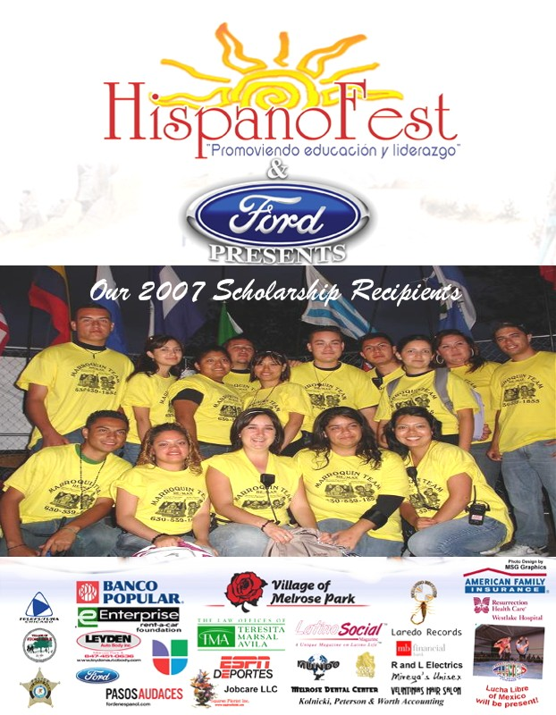
- Per capita income: $20,992 (2020)

Melrose Park is centrally located from its surrounding suburbs. It is surrounded by Stone Park (92.7% Hispanic), Franklin Park (62.2% Hispanic), Northlake (62.1% Hispanic), Maywood (36.9% Hispanic) Bellwood, Broadview, Oak Park, Elmhurst, Schiller Park, and Forest Park all just west of the City of Chicago.

Web Page: www.Hispanofestmelrosepark.com.

HispanoFest P.O. Box 1902 Melrose Park IL 60161 www.hispanofestmelrosepark.com

2026 Sponsorship Application
Name of Company (As it should appear on promotional material)

Address:

City: |  |  | State: |  |  | Zip Code:
Name of Contact Person:

Phone numbers | Work: |  |  | Fax:
Phone numbers | Cell: |  |  | Email:
Phone numbers | Other:

Yes, I will be participating as a sponsor at the level checked below:
$25,000
$15,000
$10,000
$ 7,500

Small Business Sponsors
- $2,500
$1,000
- $ 500
- $ 350
- $ 300

No, I do not want to be a major sponsor at this time, but would like to donate the following:

- Donation amount of $________________ or

- Item(s) ______________________Valued at: $ __________

___________________________________ ________________
Signature of responsible Representative Date

Please endorse and mail all donations to: HispanoFest 2026
Attn: Irene Herrera
P.O. Box 1902
Melrose Park, IL 60161

HispanoFest is an organization recognized as a tax-exempt from federal income tax. HispanoFest is currently exempt under section 501 (c)(3) of the Internal Revenue Code. HispanoFest is also classified as a public charity under 509 (a)(1) and 170 (b)(1)(A)(vi) and 170 (b)(1)(A)(vi) of the Internal Revenue Code. Any and all contributions to HispanoFest are deductible under section 170 of the Code, and HispanoFest qualifies to receive deductible bequests, devises, transfers or gifts under section 2055, 2106 or 2522 of the Internal Revenue Code.

HispanoFest P.O. Box 1902 Melrose Park IL 60161 www.hispanofestmelrosepark.com

